Redevelopment Opportunity
Asking Price: $TBD
2833 Mounds View Boulevard, Mounds View, MN
B-3 Zoning Retail/Service/Restaurant
Acreage: 1.10 acres
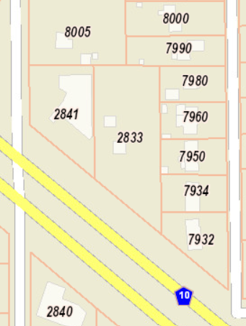
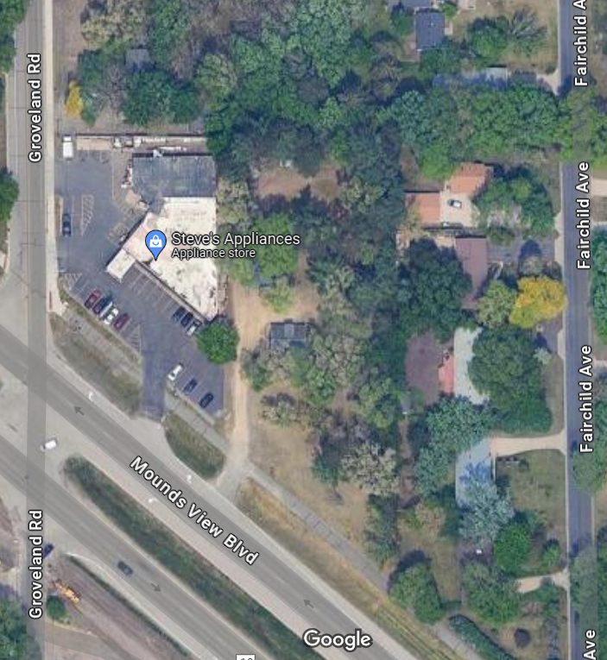

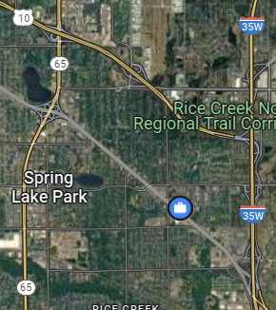
High Visibility from Mounds View Blvd (26,000 vehicles per day). Located between Hwy 65 to the West and I-35W to the East and US Hwy 10 to the North. Access from right-in, right-out.
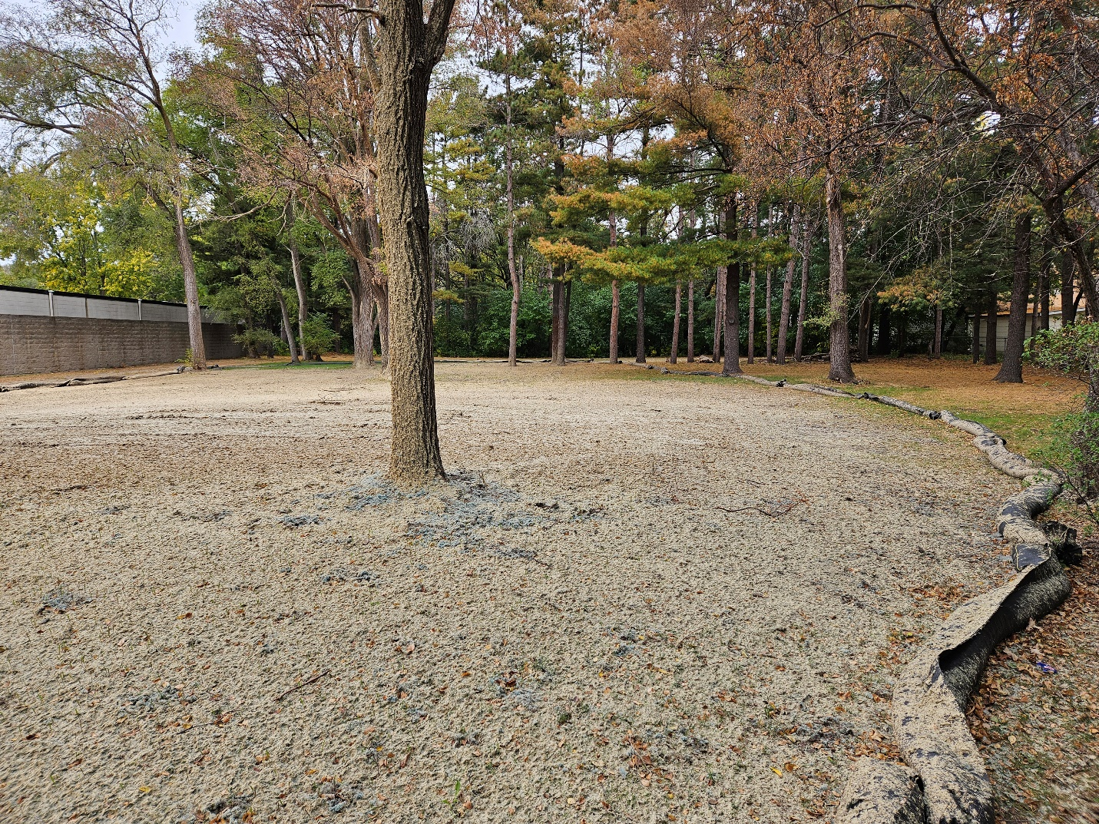
The City of Mounds View Economic Development Authority (EDA) owns the 1.10-acre parcel. The city is open to a variety of ideas for redevelopment of the parcel including retail, service, restaurant, and potentially a small mixed-use development. The price of the lot is to be determined based on the type of development. A Public Hearing is required before the sale and the developer must break ground no later than 1 year after signing the purchase agreement. This was an R-1 single-family home which was removed and it now a vacant lot.
The developer must submit a concept drawing to the EDA and proposal explaining the intent of the project. The EDA will decide if the project fits the vision, then determine the land price.
Please submit your proposal/ideas to:
Brian Beeman M.P.A.
Assistant City Administrator
City of Mounds View
763-717-4029
Brian.beeman@moundsviewmn.org

